NAME OF THE PROJECT:

Intellí Learning(A free learning management system)

DETAILS OF THE PROJECT MEMBERS:

Name: Deepam Chetry

Reg.No:12008097

Roll NO: RK20TSA24

Name: Dhruv Jain

Reg.No:12007428

Roll NO: RK20TSA25

DURATION: 24 Days

DATE OF START: 01/04/2021

DATE OF END: 24/04/2021

ABOUT THE PROJECT

Intellí Learning is a website which provides best free video resources and also tests so that the

Students can test themselves along with learning.

The website has the following pages:

1. Home – This is the heart of the website where you get to know about all computer science related topics along with related videos of the topic to kick start your learning.

Highlights of the page

1. Log in option
2. Website logo (Made by the members of the group)
3. Search bar
4. Access to other pages of the website
5. Info about all the topics related to computer science field
6. Link to other paid websites which can further help your learning
7. Option to subscribe mailing list
8. Contact Us form
9. Copyright

To make this Page we have mainly used CSS grid layout, font awesome icons, CSS animations, JavaScript, HTML forms

1. Videos – In this page we have provided specific video for a specific topic along with all the videos of the major topic in which it lies in for example since html, CSS and JavaScript are a part of Frontend development so specific videos can be found for them along with all the videos of frontend development topic.

Highlights of the page

1. Website logo
2. Search bar
3. Videos of topics as well as Subtopics
4. Side Navigation Bar
5. Copyright

To make this Page we have mainly used CSS grid layout, CSS animations, JavaScript

1. Tutors – In this we have provided tutor profile cards which includes tutor’s photo, current working status, university from which the graduated, links to their websites and social media (the links are not fake and does leads to tutor’s social media handles)

Highlights of the page

1. Website logo
2. Search bar
3. Tutor’s profile cards
4. Copyright

Highlights of the page

To make this page we have mainly used CSS Grids, CSS box model.

1. Test Yourself – In this we have provided a link to a very famous test service along with beautiful front end.
2. About Us – In this page we have provided information about our website, our mission, our beliefs and at the bottom a link to bottom page.

CONTRIBUTION MEMBER WISE

|  |  |  |  |
| --- | --- | --- | --- |
| Member details | Page1 | Page2 | Page3 |
| Dhruv Jain  Roll No – RK20TSA25  Reg No - 12007428 | Title – Home  Features - Login option, info about topics, mailing list, contact us  Technologies - CSS grid layout, font awesome icons, CSS animations, JavaScript, HTML forms | Title – Videos  Features - Videos of topics as well as Subtopics, Side Navigation Bar  Technologies - CSS grid layout, CSS animations, JavaScript | Title – Tutor  Features - tutor profile cards which includes tutor’s photo, current working status, university from which the graduated, links to their websites and social media  Technologies - CSS Grids, CSS box model |
| Deepam Chetry  Roll No - RK20TSA24  Reg No - 12008097 | Title - Test Yourself  Features - link to a very famous test service along with beautiful front end.  Technologies – HTML, CSS, JavaScript | Title – About Us  Features- Information about our website, our mission, our beliefs and at the bottom a link to bottom page.  Technologies – HTML, CSS |  |
| Shaik Khaja Moeen  Roll No –  Reg No - 12006898 | None  (Refused to contribute in the project) | None  (Refused to contribute in the project) |  |

HOME

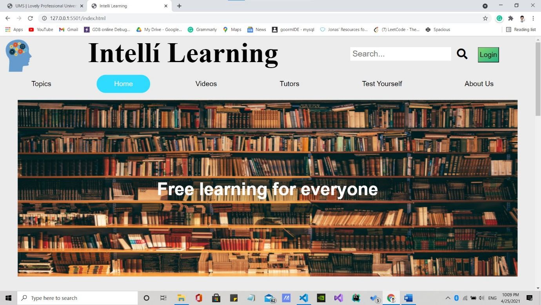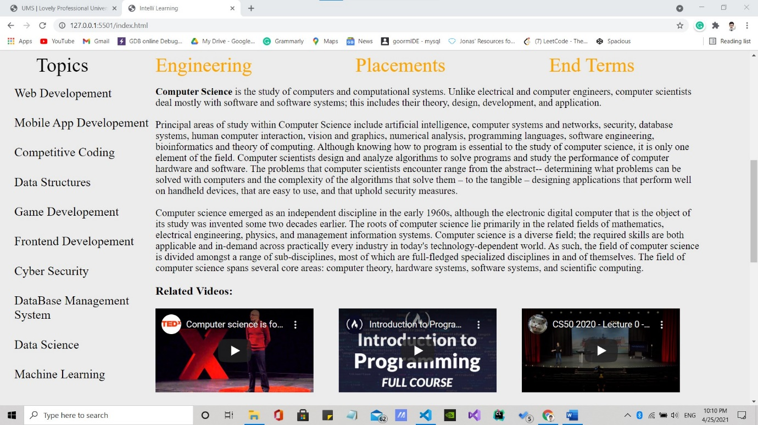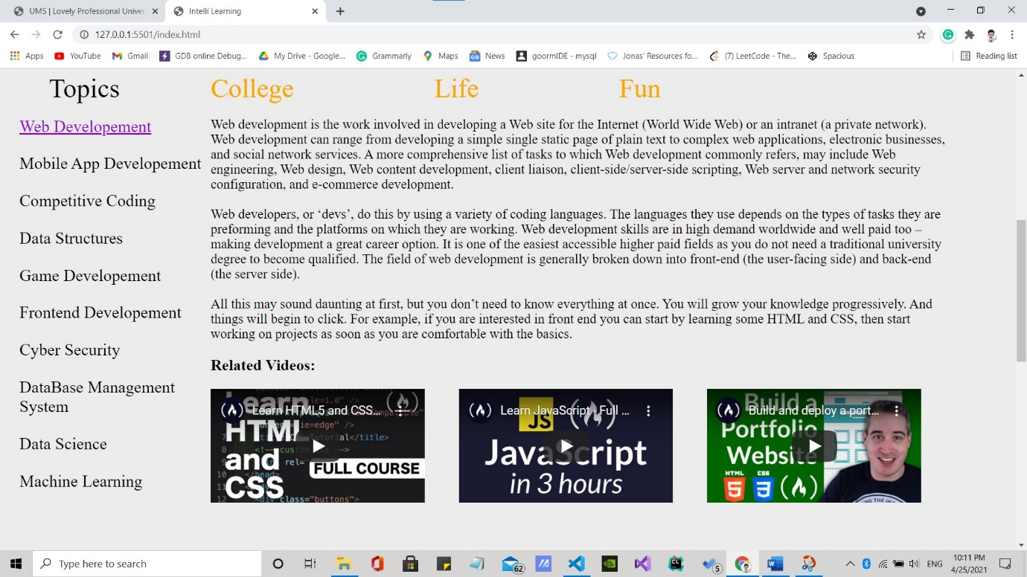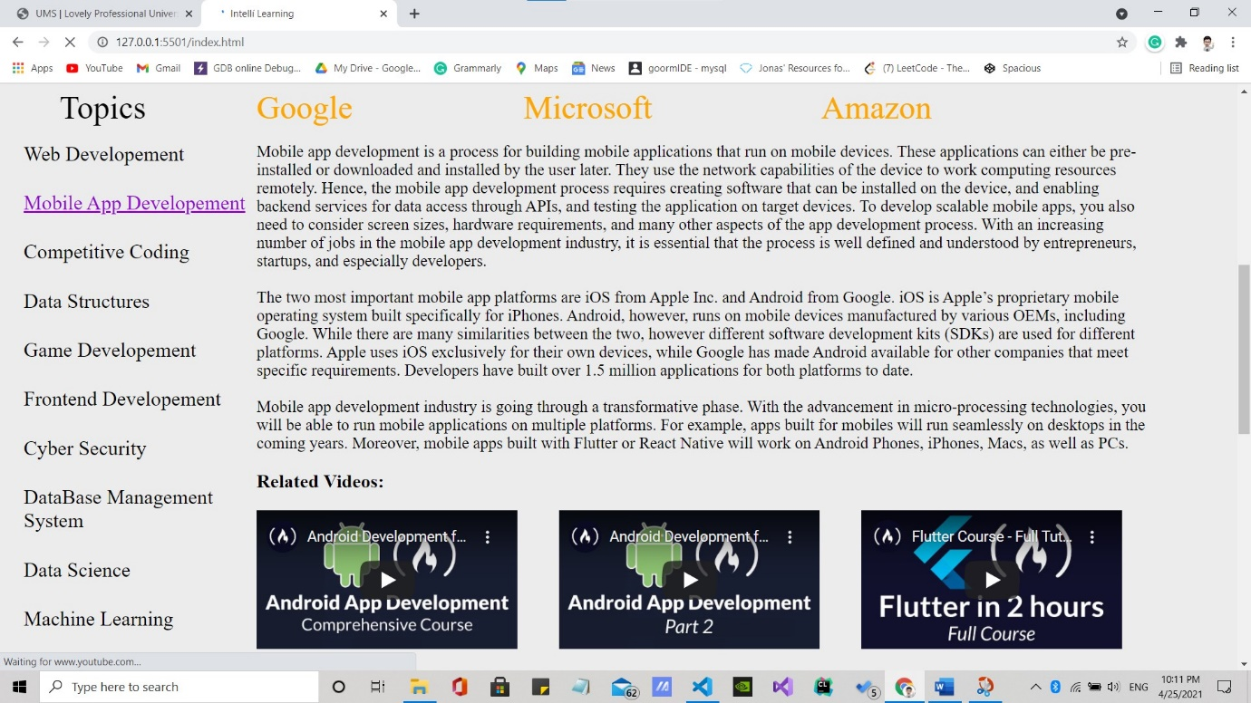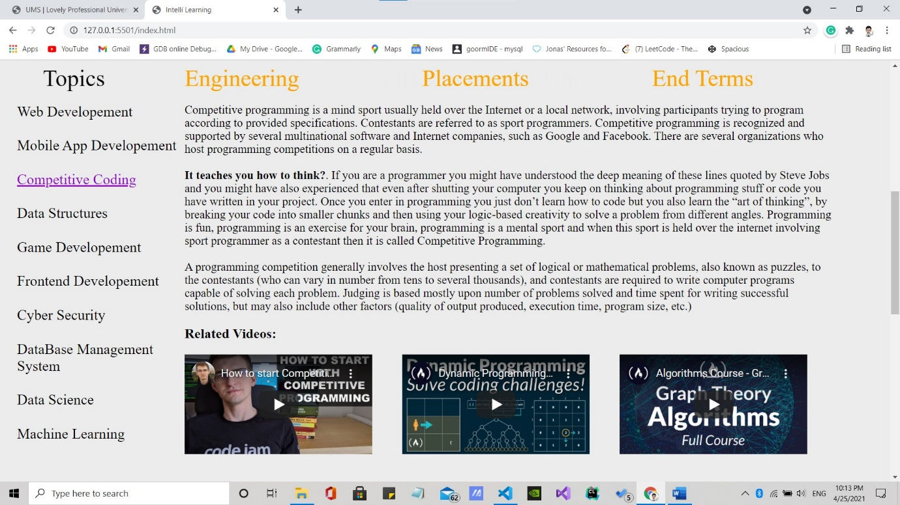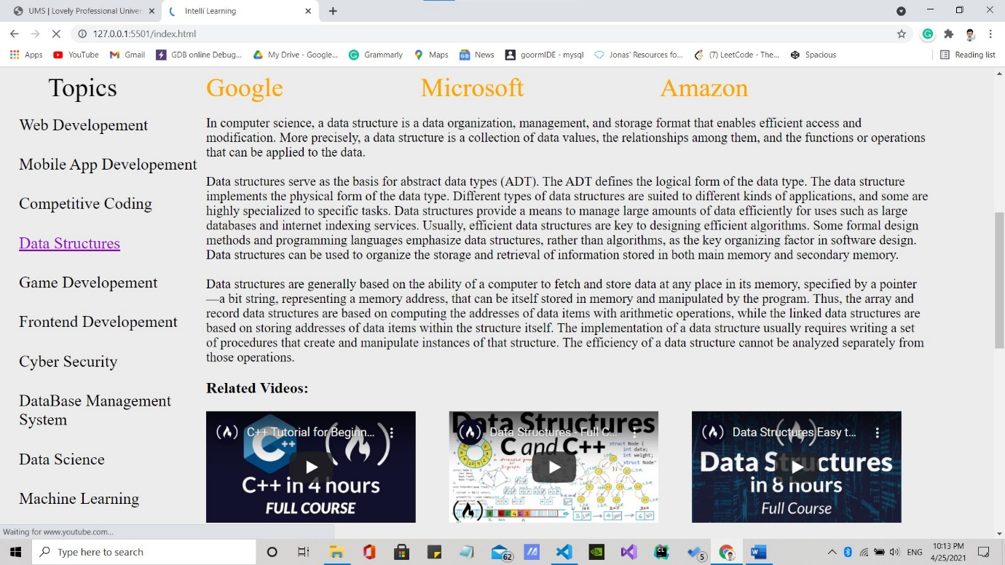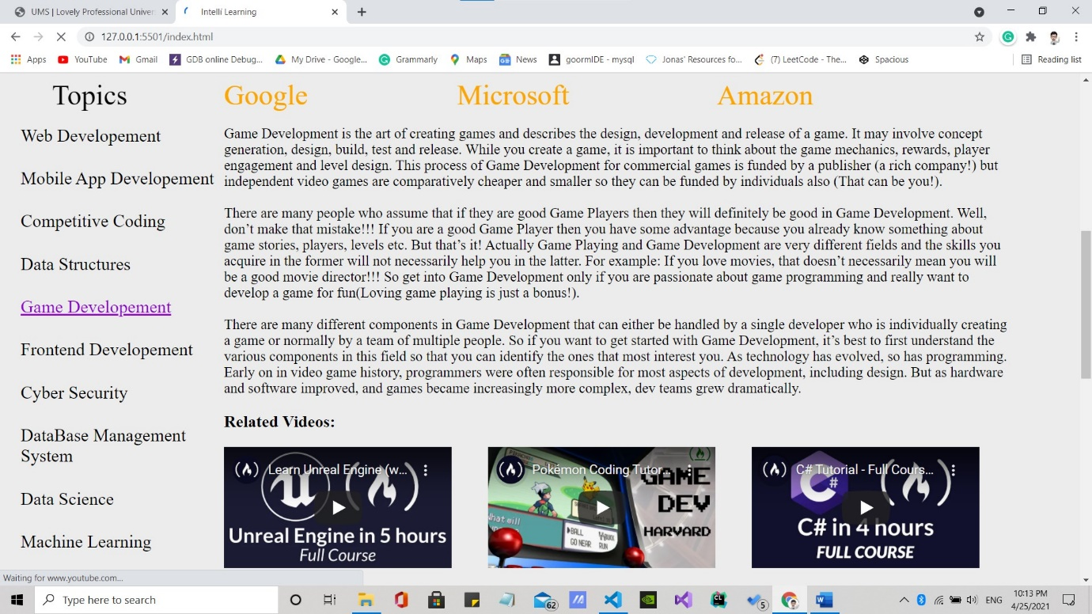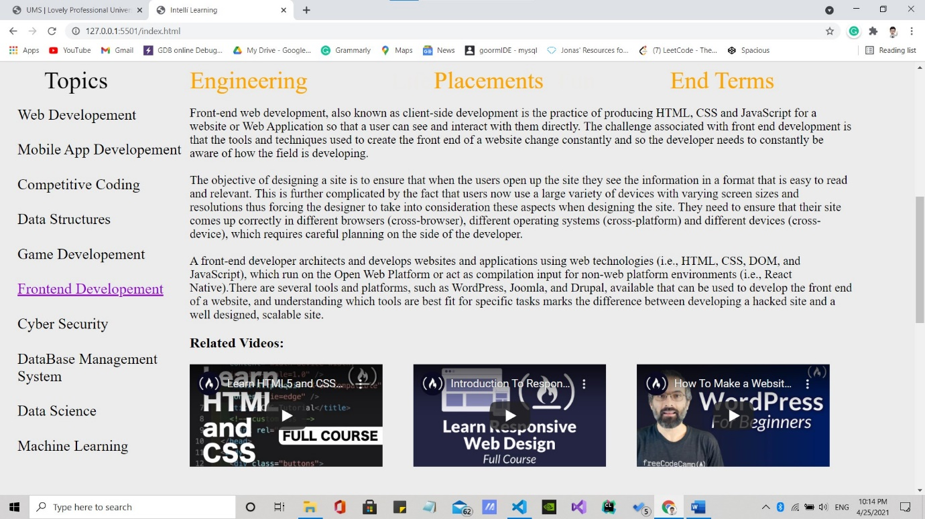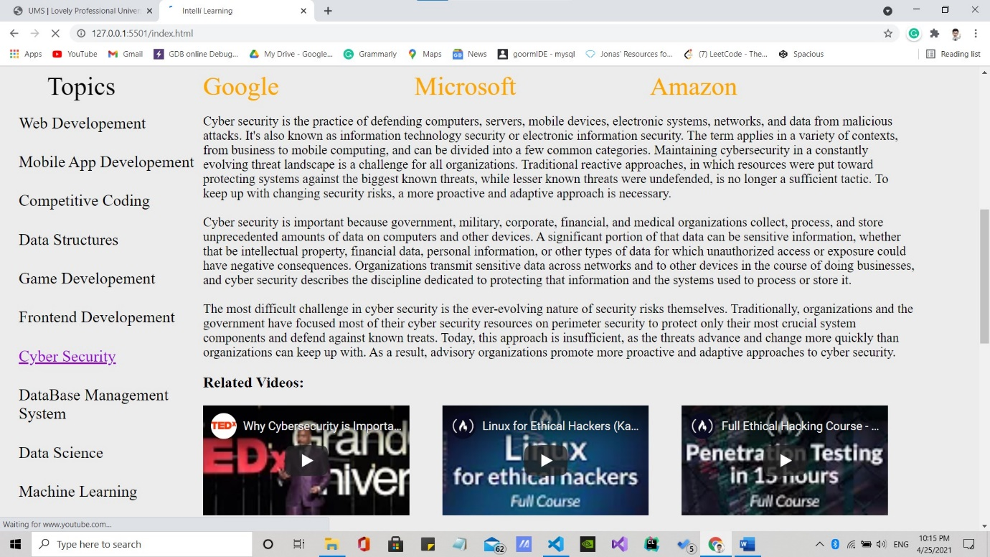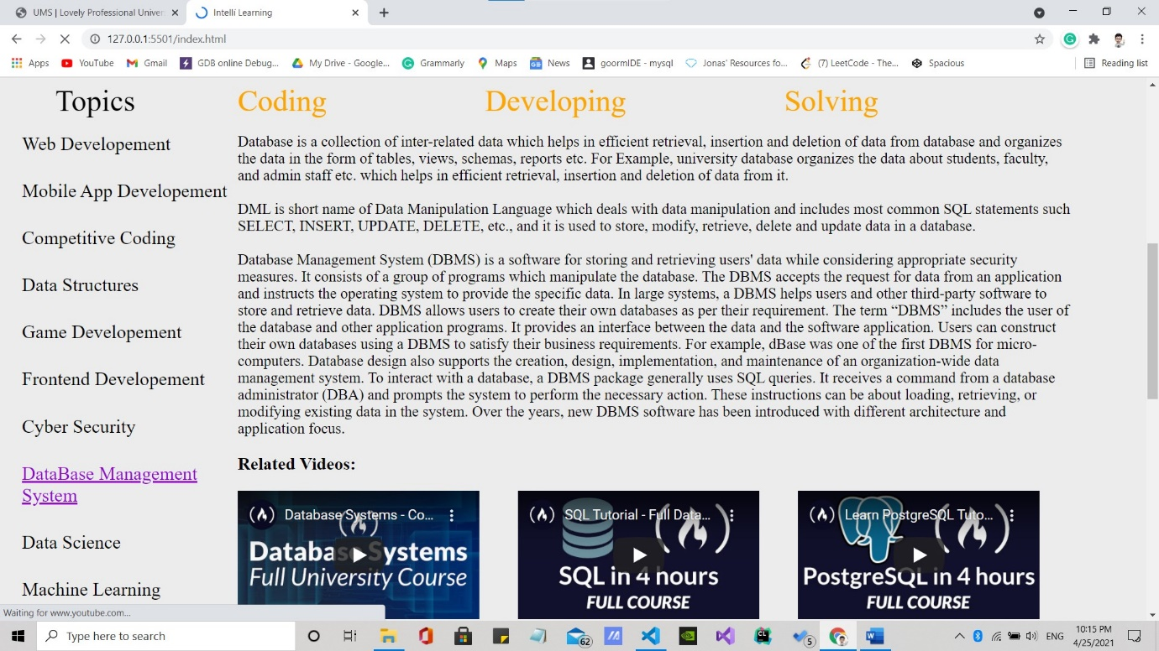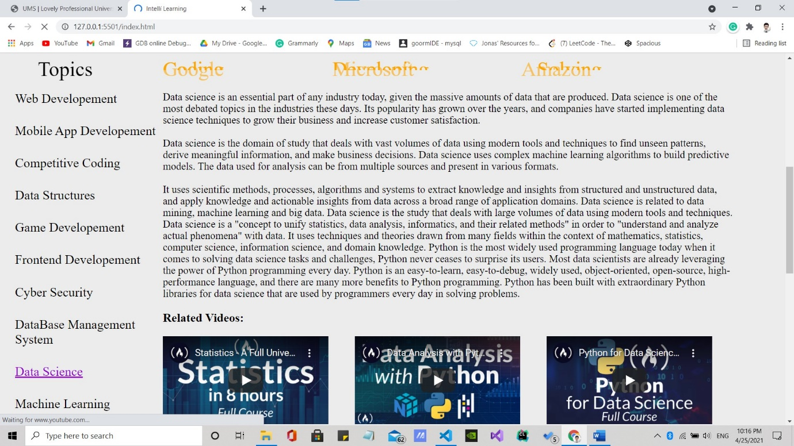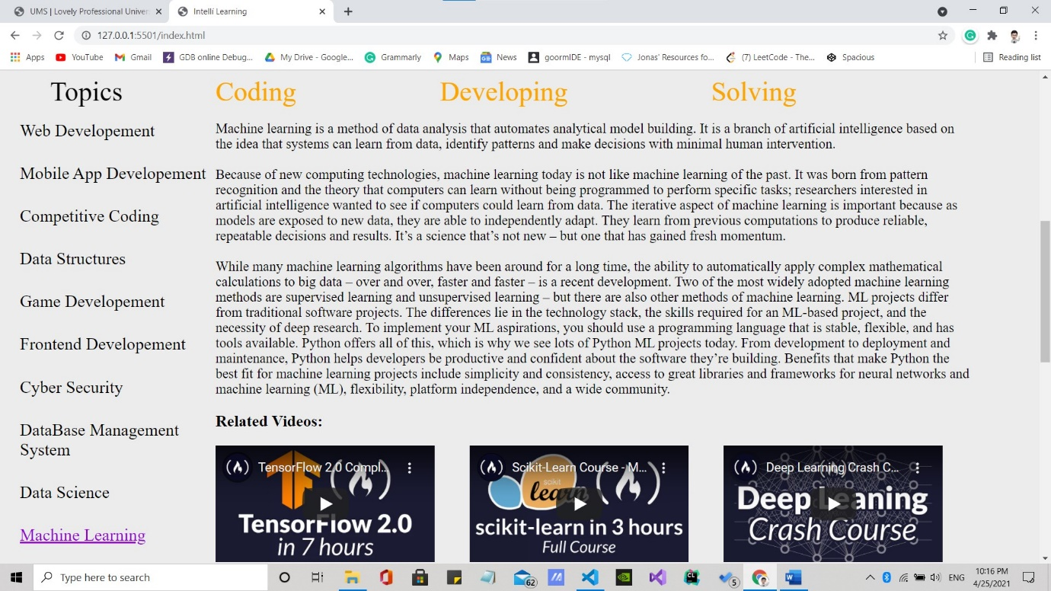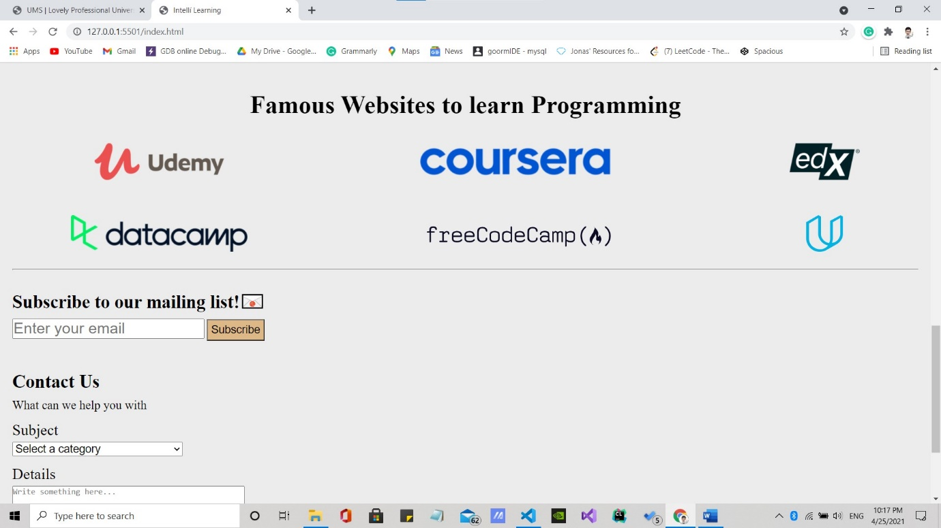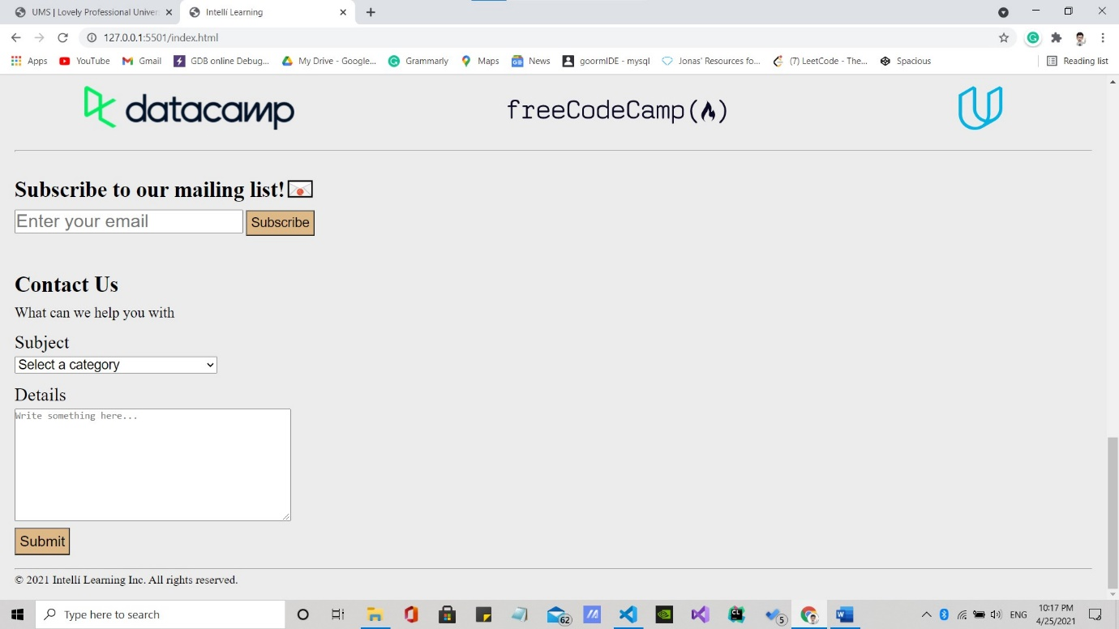

VIDEOS

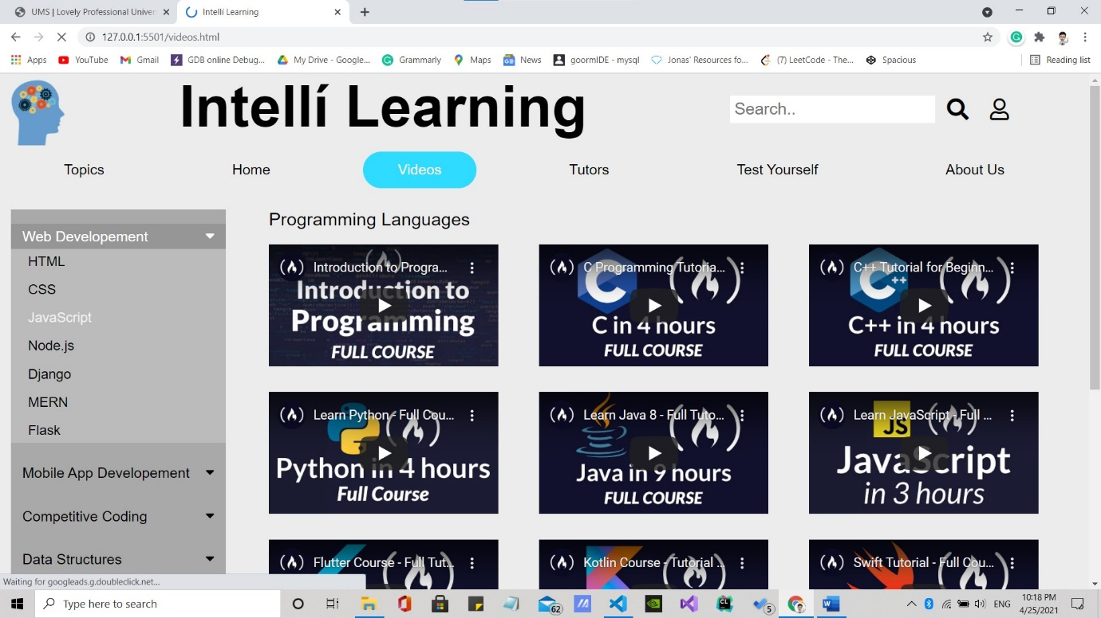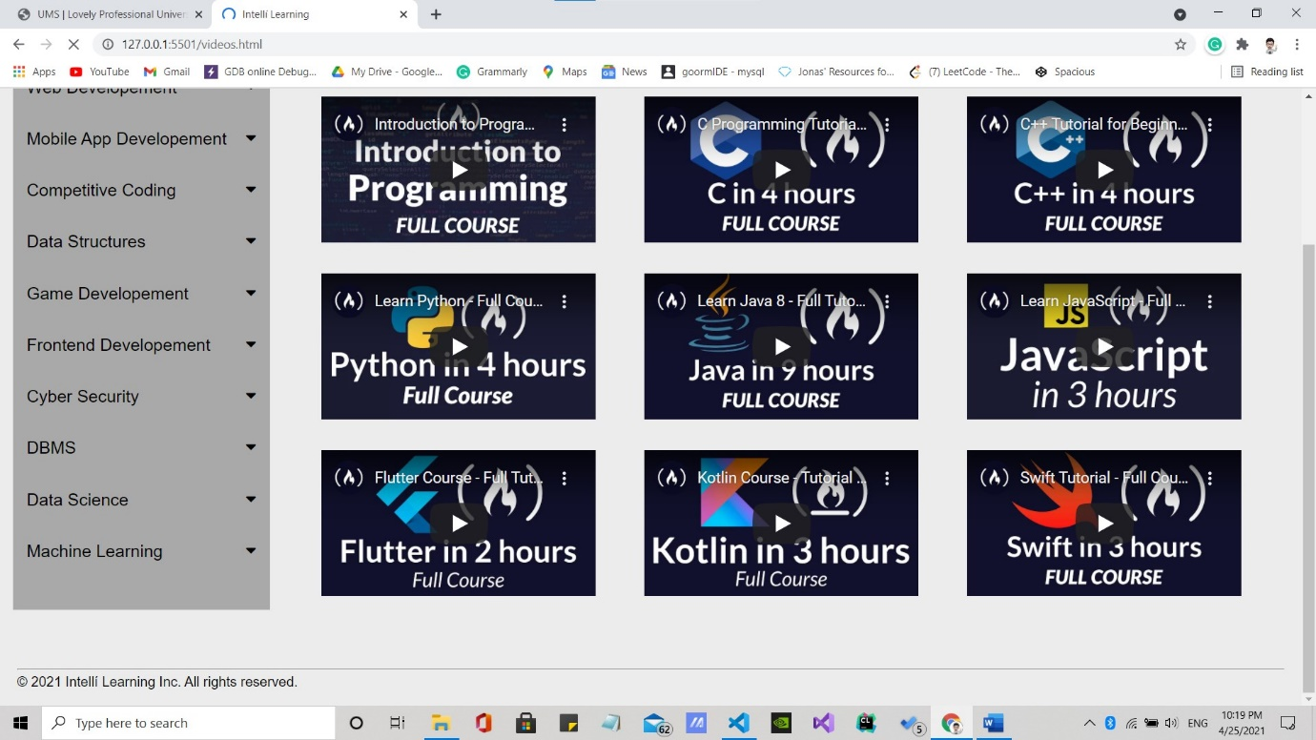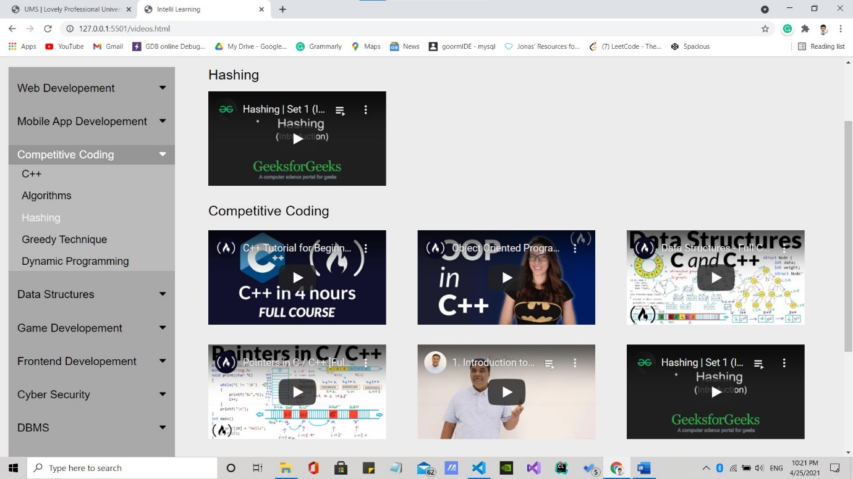

TUTORS

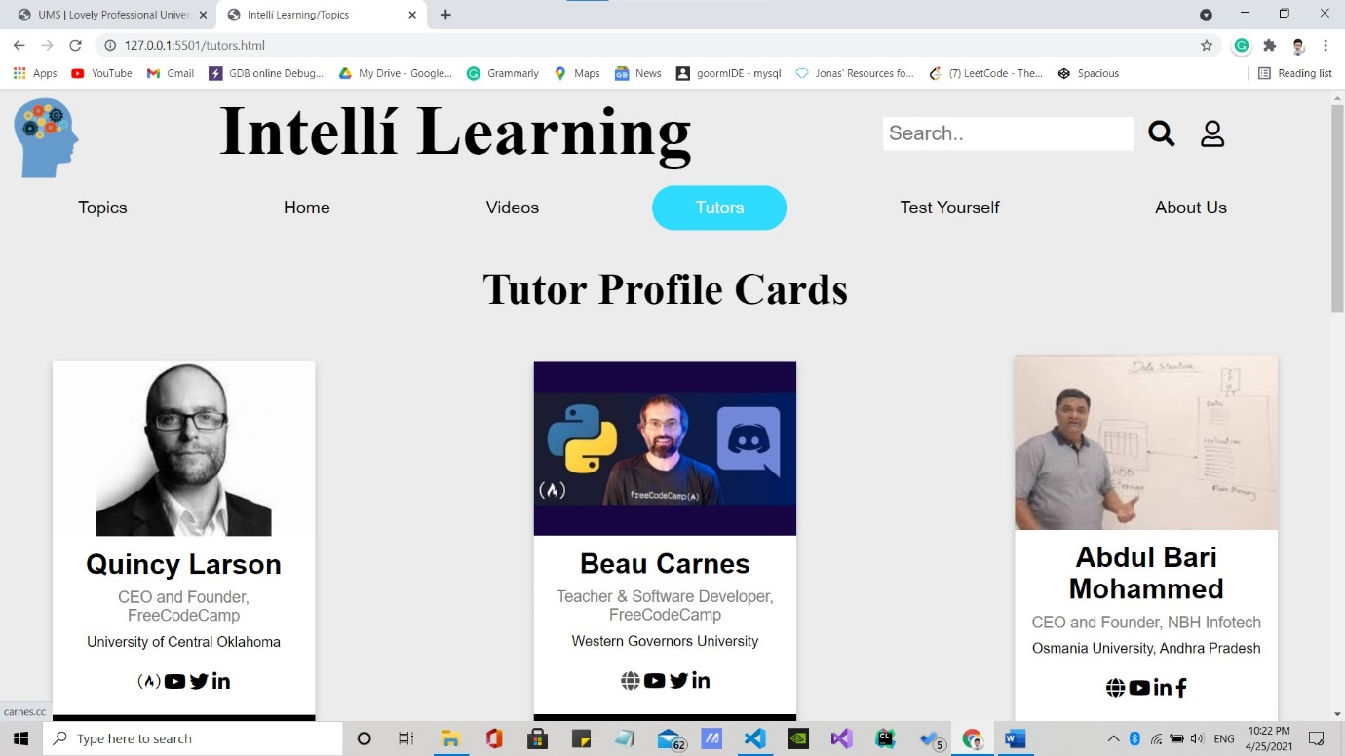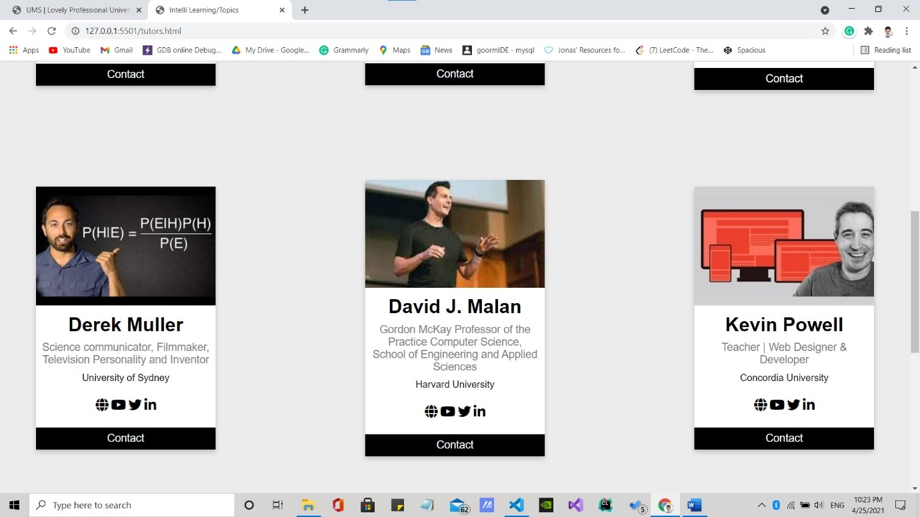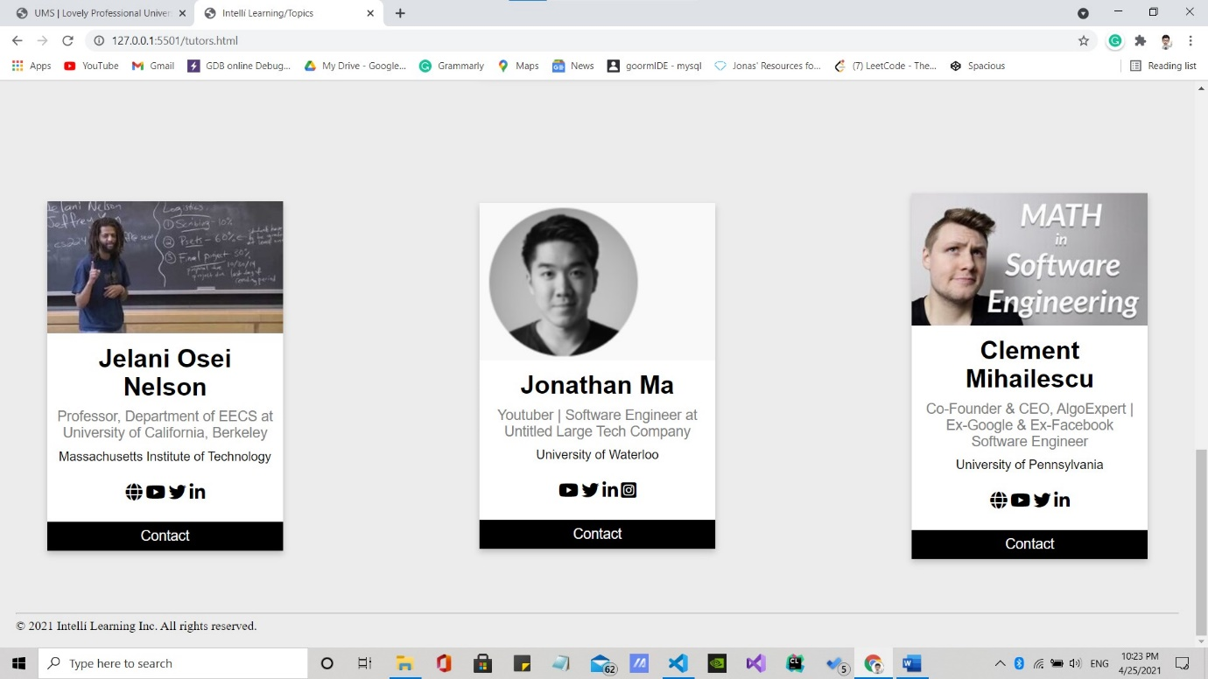

TEST YOURSELF

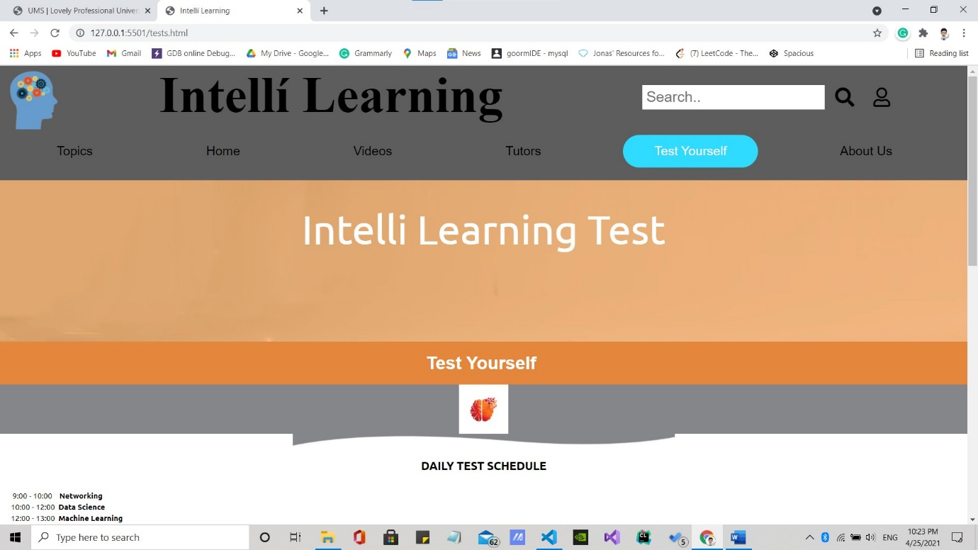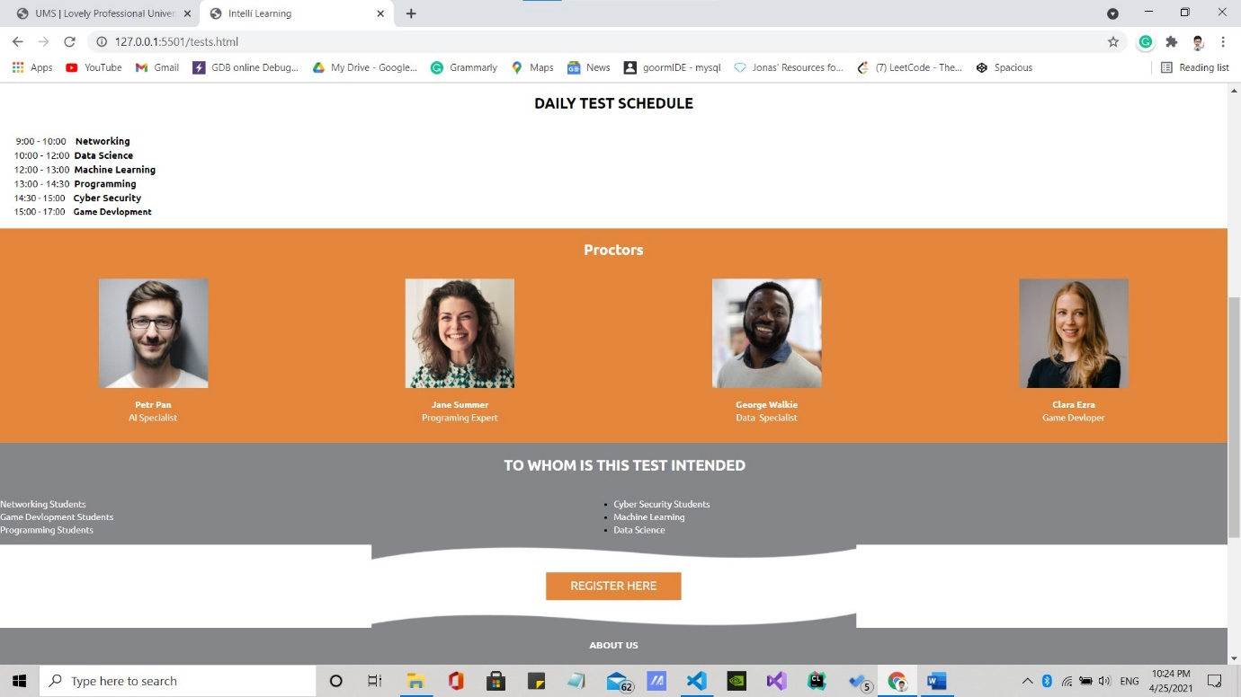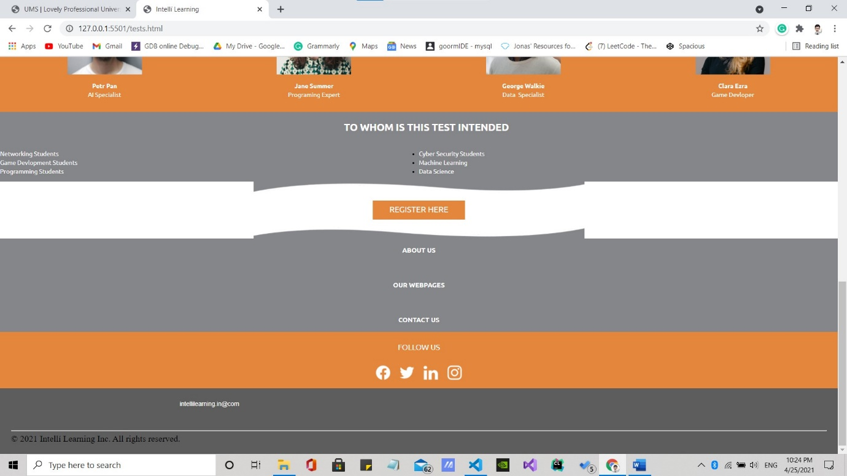

ABOUT US

